## Front End Engineering-II

Project Report

Semester-IV (Batch-2022)

Title of the Project: -

Food Restraunt



**Supervised By: Submitted By:**

Raveesh Samkaria Swapnil Dhamija

Roll Number: -2210990881

Group - 13

**Department of Computer Science and Engineering**

## Chitkara University Institute of Engineering & Technology,

## Chitkara University, Punjab

**Abstract**

This project report details the development of a front-end website for a food restaurant, leveraging HTML, CSS, and JavaScript. With a strong emphasis on user engagement and intuitive navigation, the website is designed to effectively communicate the restaurant's offerings and expertise to prospective diners.

Through the implementation of responsive design and accessibility features, the project underscores the restaurant's commitment to providing exceptional digital experiences. The website's interactive elements and visually appealing layout aim to enhance the user's journey, enticing them to explore the restaurant's menu and ambiance.

**Table of Contents**

| Sr.no | Section | Page No |
| --- | --- | --- |
| 1. | Introduction | 4 |
| 2. | Problem Statement | 5 |
| 3. | Technical Details | 7 |
| 4. | File Structure | 8 |
| 5. | Result | 9 |
| 6. | References | 41 |

**Introduction**

In today's digital era, a compelling online presence is indispensable for restaurants aiming to captivate their audience and showcase their culinary offerings. The development of an aesthetically pleasing and user-friendly website is crucial, especially for food establishments seeking to stand out in the competitive hospitality industry. This report chronicles the creation and deployment of a front-end website for a food restaurant, employing a blend of HTML, CSS, and JavaScript.

The website acts as a virtual gateway to the restaurant, providing visitors with a comprehensive glimpse into its menu, ambiance, team, and contact details. By incorporating thoughtful design elements and ensuring a seamless user experience, the website strives to captivate visitors and effectively convey the restaurant's unique identity and gastronomic expertise.

This introduction provides an overview of the project's objectives, underscoring the significance of a well-crafted website in today's digital landscape for restaurants. Subsequent sections will delve into the technical aspects of the website's development, highlighting key design considerations, features, and implementation strategies. Furthermore, the report will address the encountered challenges and the innovative solutions devised to surmount them, offering valuable insights for future website development endeavors. Ultimately, this project serves as a testament to the fusion of culinary artistry and digital innovation, showcasing the restaurant's dedication to delivering exceptional dining experiences to its patrons.

**Problem Statement**

In today's competitive culinary landscape, restaurants are increasingly challenged to differentiate themselves and attract customers in a saturated market. A key challenge faced by many restaurants is the lack of a strong online presence and an engaging digital platform to showcase their unique offerings effectively. Without a compelling website, restaurants struggle to reach and engage with their target audience, resulting in missed opportunities for growth and customer acquisition.

This project aims to address these challenges by developing a front-end website for a food restaurant, leveraging HTML, CSS, and JavaScript. The website will serve as a digital storefront for the restaurant, offering visitors a comprehensive glimpse into its menu, ambiance, team members, and contact information. Through strategic design choices and seamless user experience, the website will seek to engage visitors and convey the restaurant's unique brand identity and culinary expertise effectively.

By creating a visually appealing and user-friendly website, the project seeks to enhance the restaurant's online presence, attract new customers, and ultimately drive business growth. The successful implementation of this project will not only benefit the restaurant but also serve as a valuable case study for other restaurants looking to enhance their digital presence and engage with their audience more effectively.

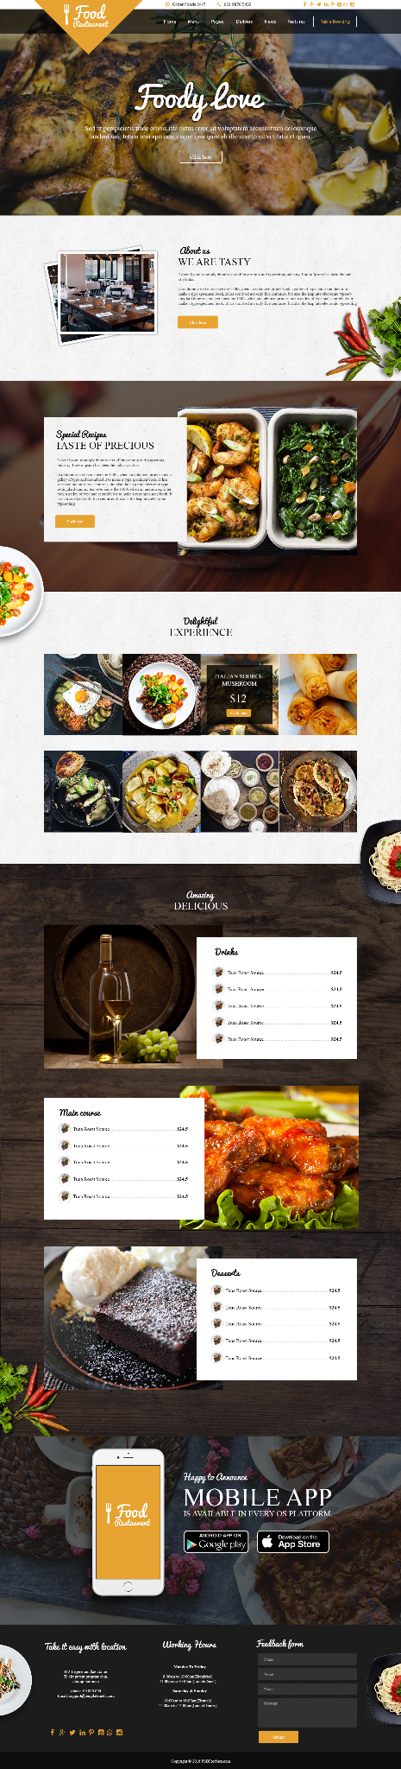

**Technical Details**

The front-end website for the design agency was constructed with a minimalist approach, employing only essential technologies to ensure a streamlined user experience. Here are the primary technical details of the project:

* **HTML Structure:** The website's structure was crafted using semantic HTML markup to enhance accessibility and clarity. Each page was organized with appropriate tags to facilitate straightforward navigation and readability.
* **CSS Styling:** Cascading Style Sheets (CSS) were utilized for styling the website's layout, typography, and color schemes. Custom CSS rules were applied to maintain a consistent visual design across the site while optimizing load times and code simplicity.
* **Responsive Design:** Responsive design principles were implemented to ensure the website's compatibility with various devices and screen sizes. Media queries and flexible layouts were employed to adapt the content and design elements responsively without reliance on frameworks.
* **JavaScript Functionality:** JavaScript was exclusively utilized for essential functionality, primarily for smooth scrolling to different sections of the website via the navigation bar. This lightweight implementation ensured efficient performance without compromising user experience.

**File Structure: -**

* **index.html:** This file serves as the main entry point for the website. It contains the

HTML markup defining the structure and content of the web pages. Within this file, sections such as the header, navigation bar, main content area, footer, and any additional elements are defined.

* **style.css:** The CSS file contains the styling rules that dictate the visual presentation of the website. This includes defining colors, fonts, layout properties, and any other stylistic elements. Selectors within this file target specific HTML elements or classes to apply the desired styles.
* **index.js**: This JavaScript file contains the client-side scripting logic for the website. In this minimal setup, the primary functionality may include smooth scrolling to different sections of the page, as indicated by the navigation bar
* **Images folder:** This folder contains all the images used throughout the website. Images may include logos, background images, or any other visual assets required to enhance the design and content presentation. Proper organization within this folder helps maintain the clarity and accessibility of image resources.
* **PSD file**: This PSD (Photoshop Document) file contains the original design mockup created using Adobe Photoshop. While not directly utilized in the website's development, it serves as a reference for design elements, layout, and visual styling.

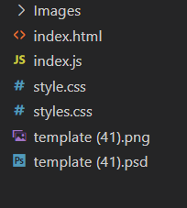

**Result**

Webpage Screenshots: -

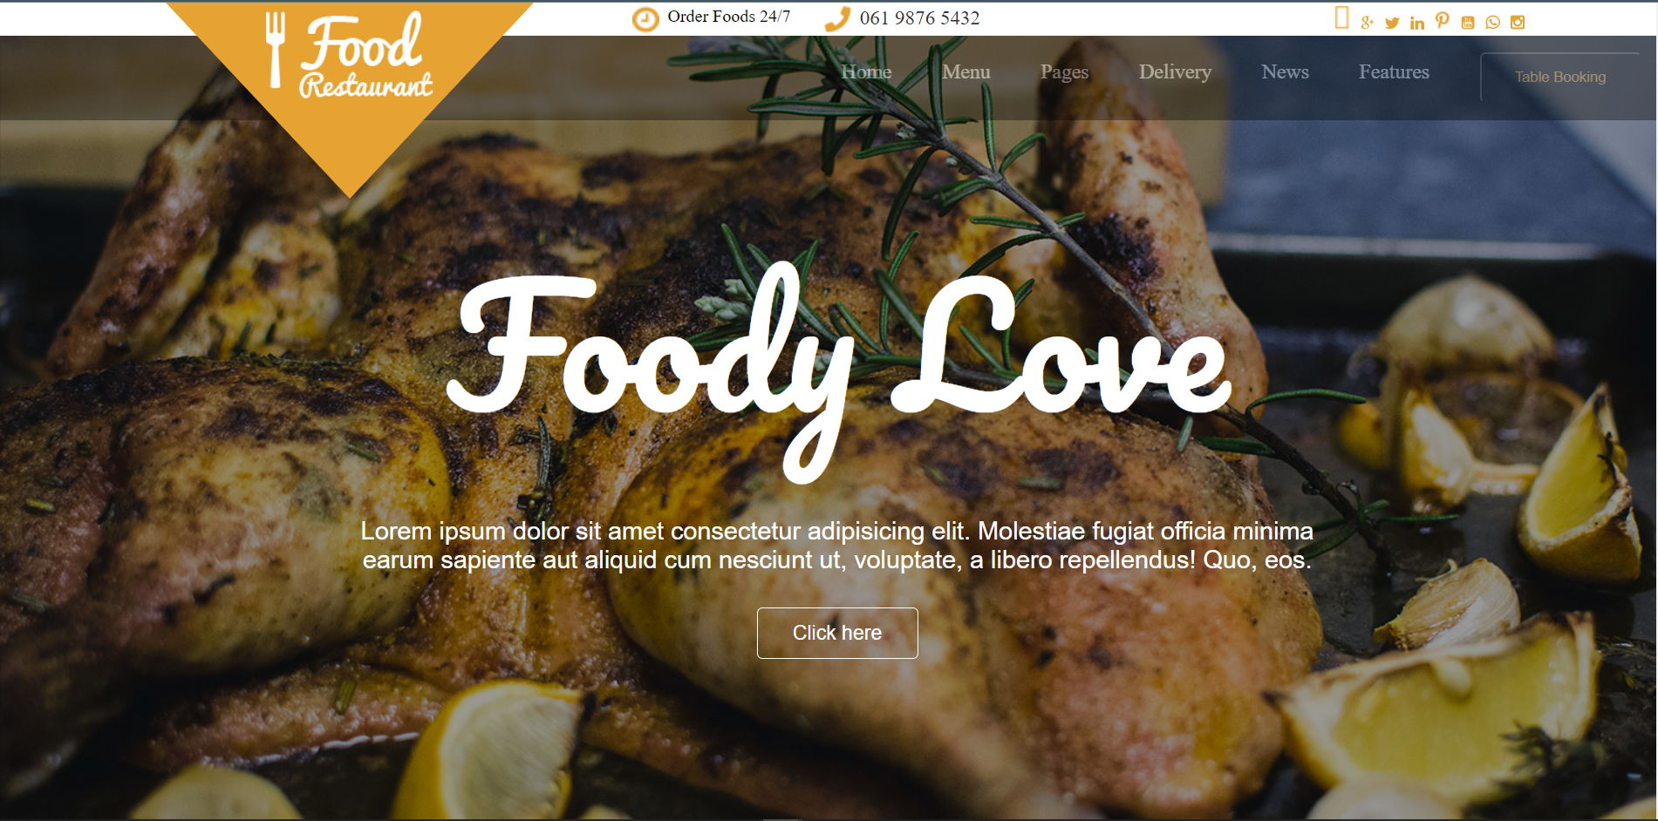

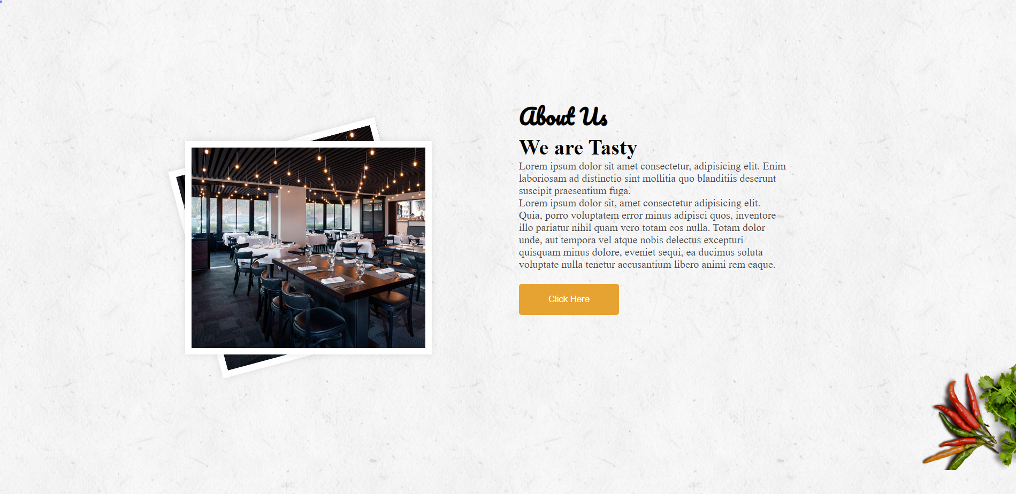

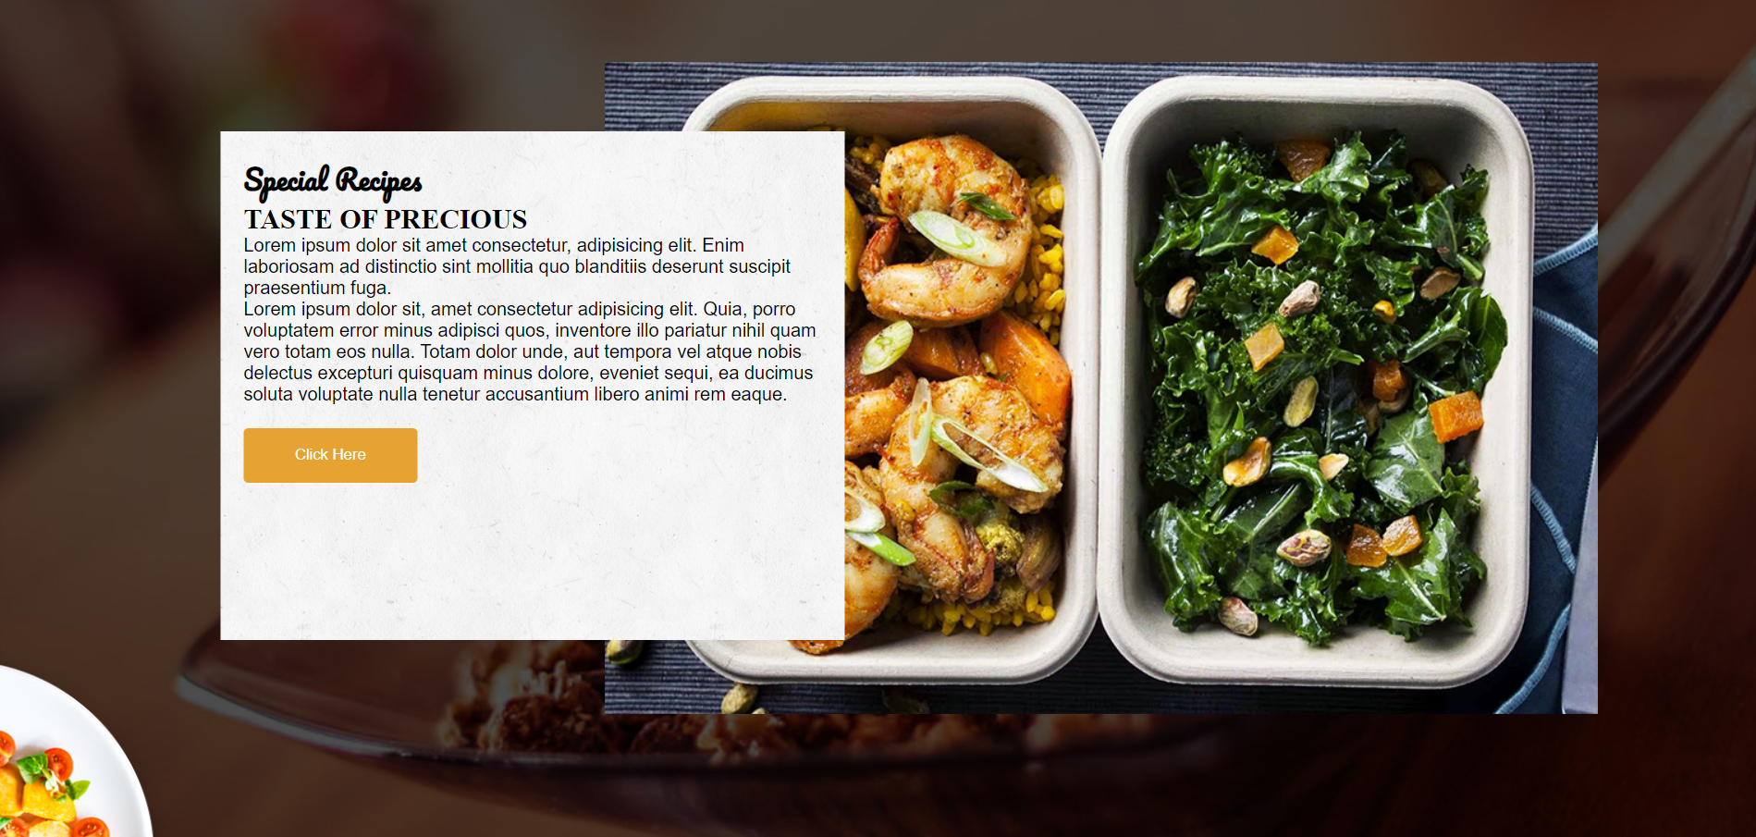

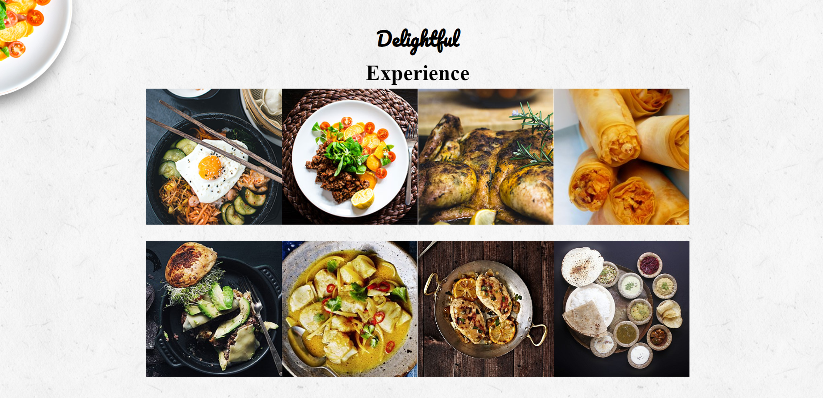

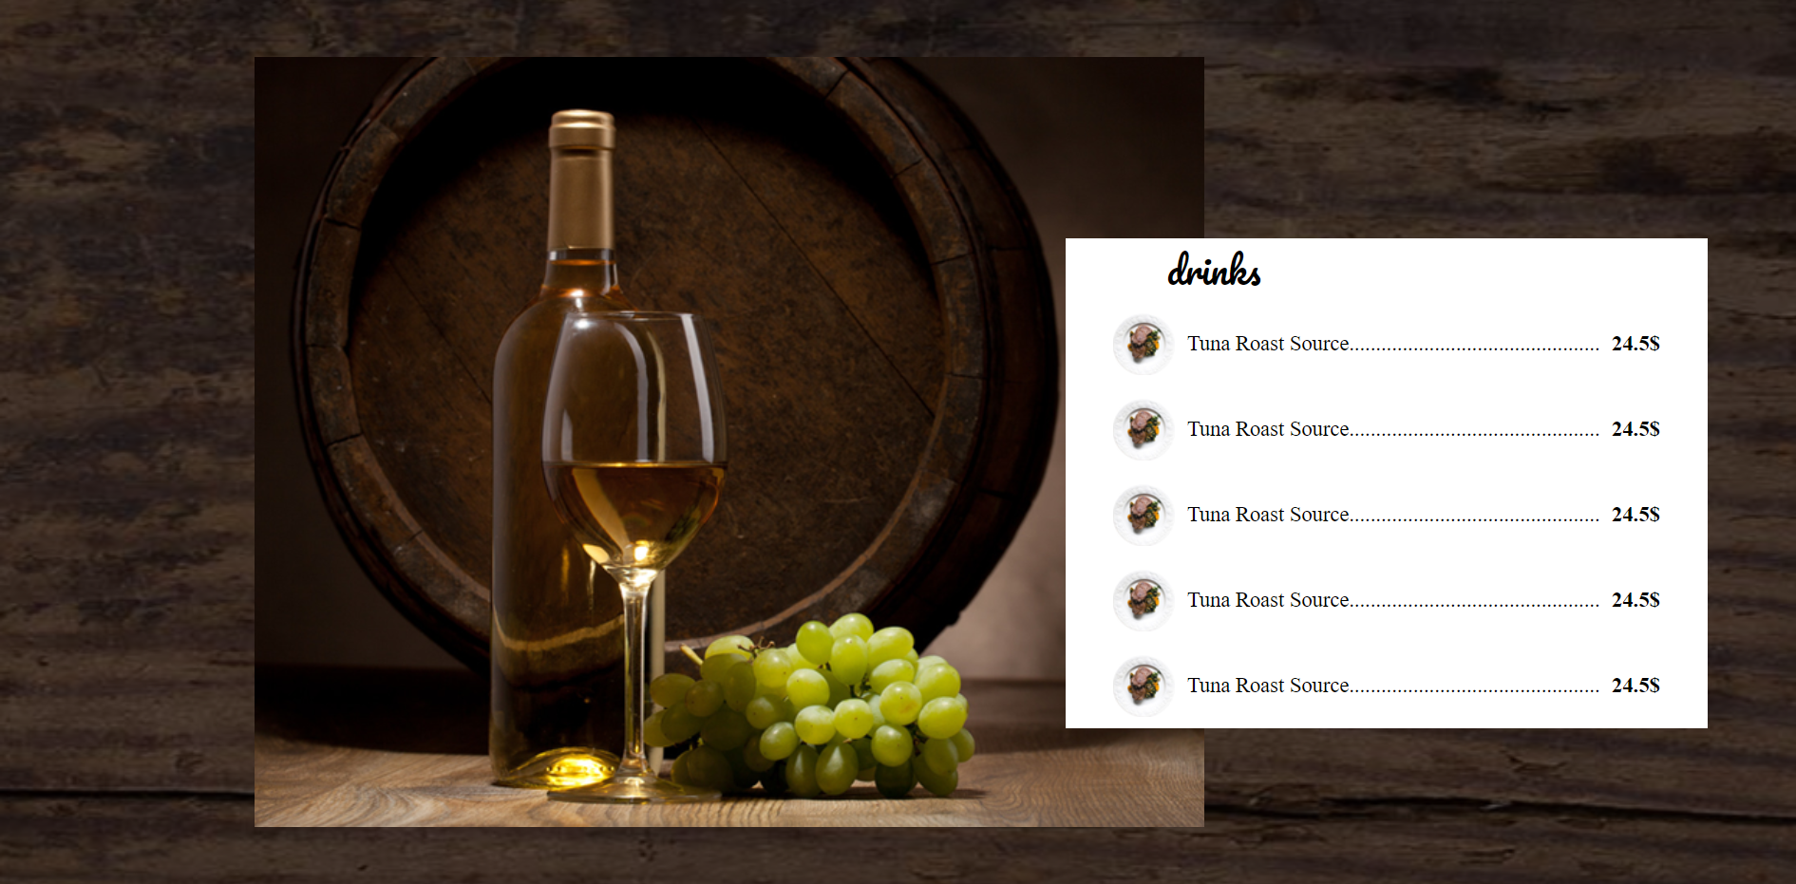

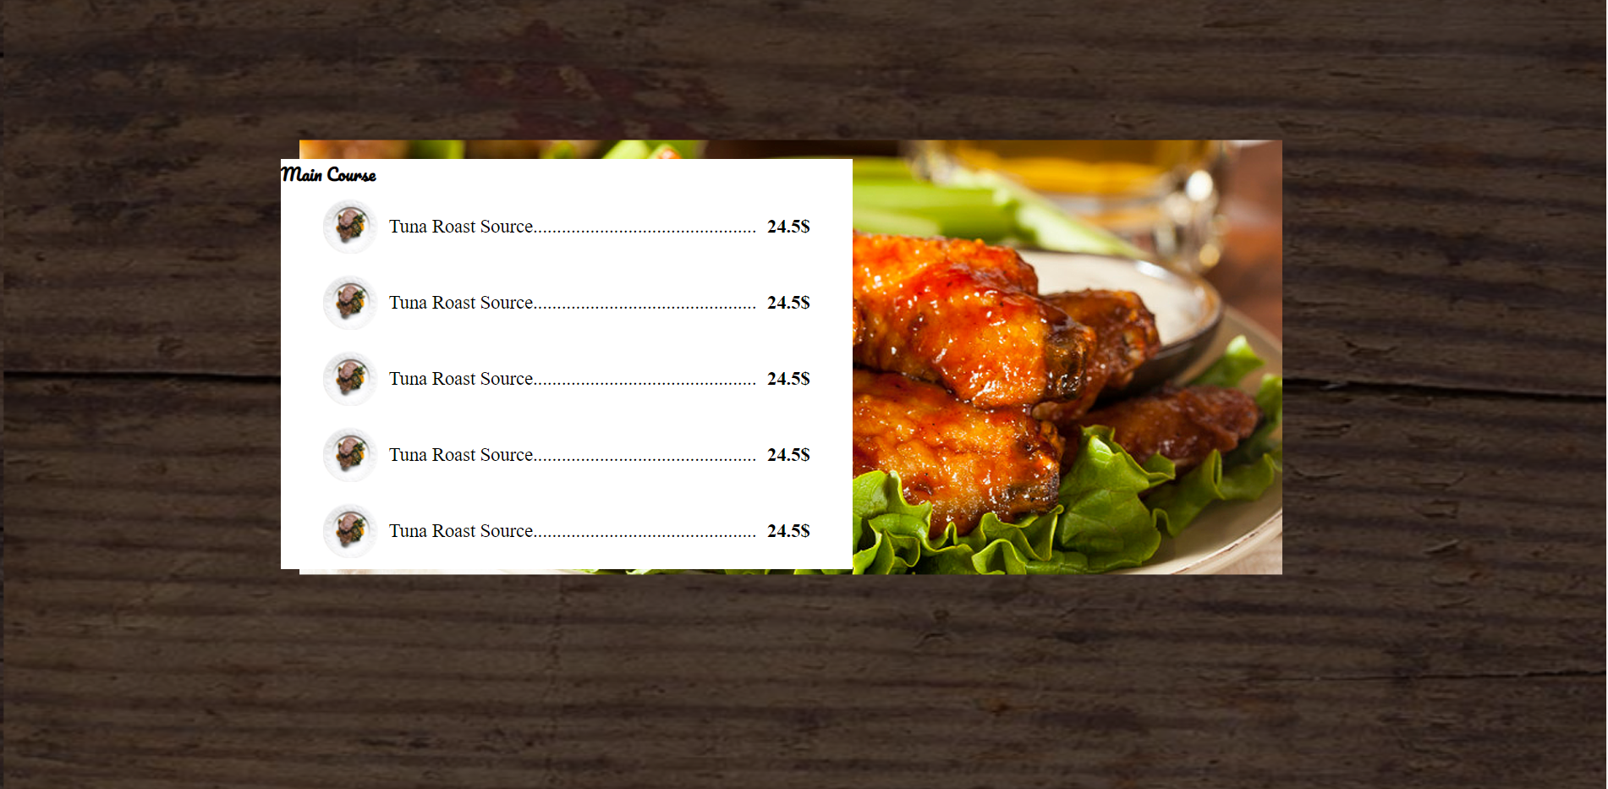

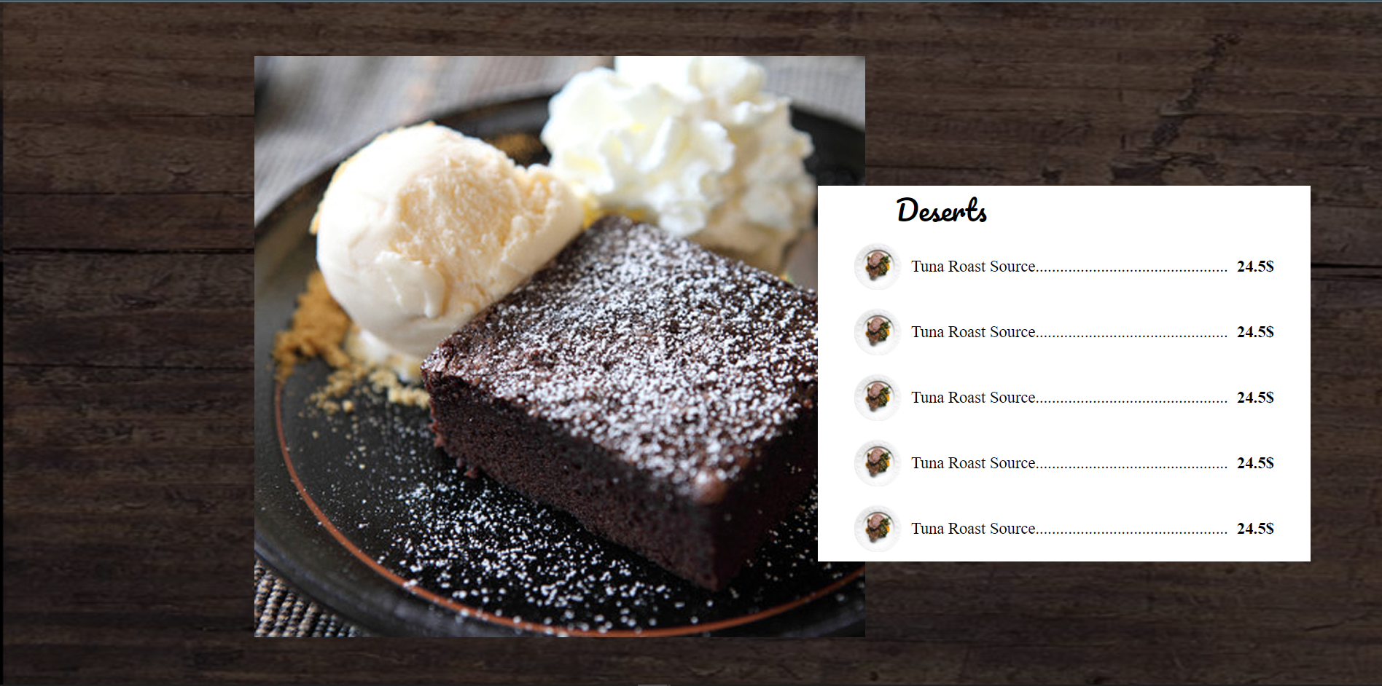



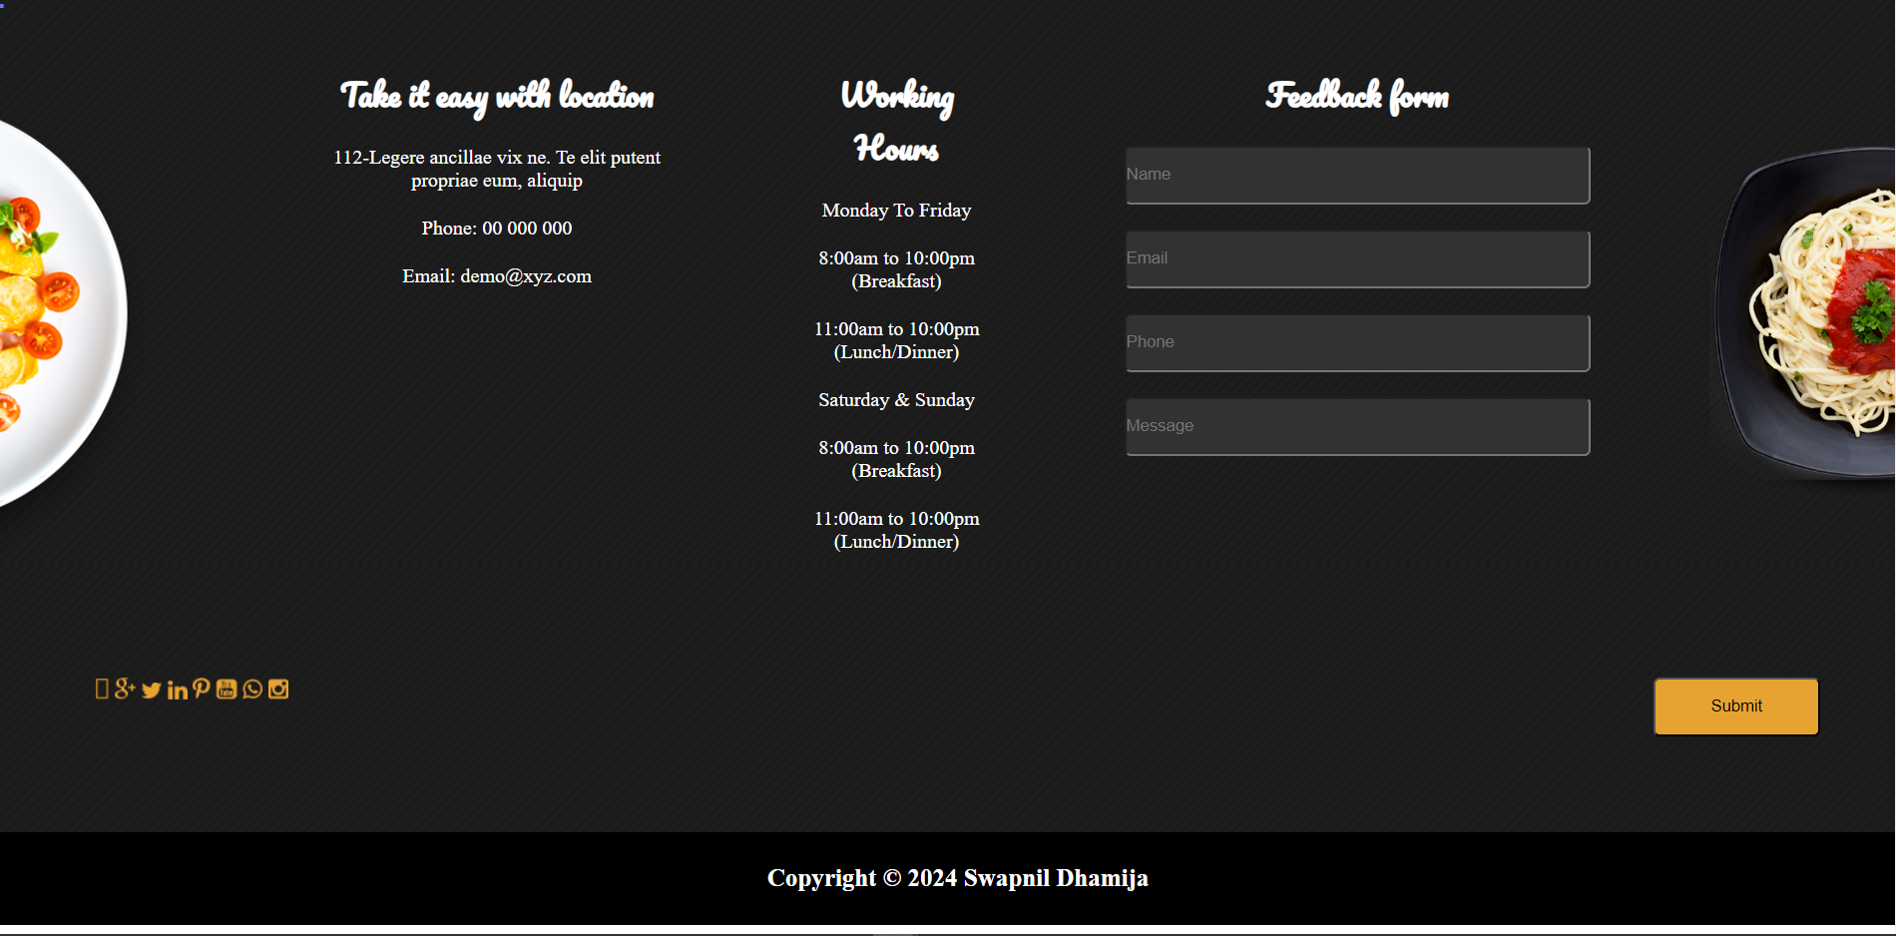

**\**

**Code:-**

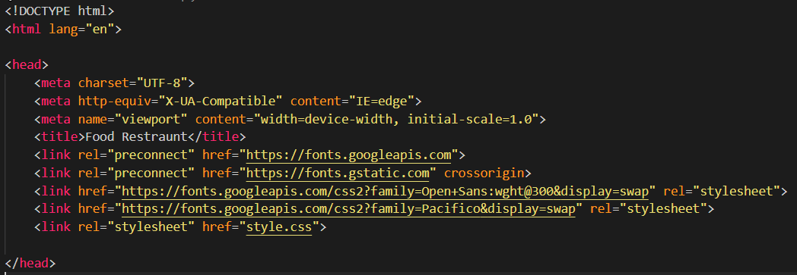

***Figure 1 Head Tag***

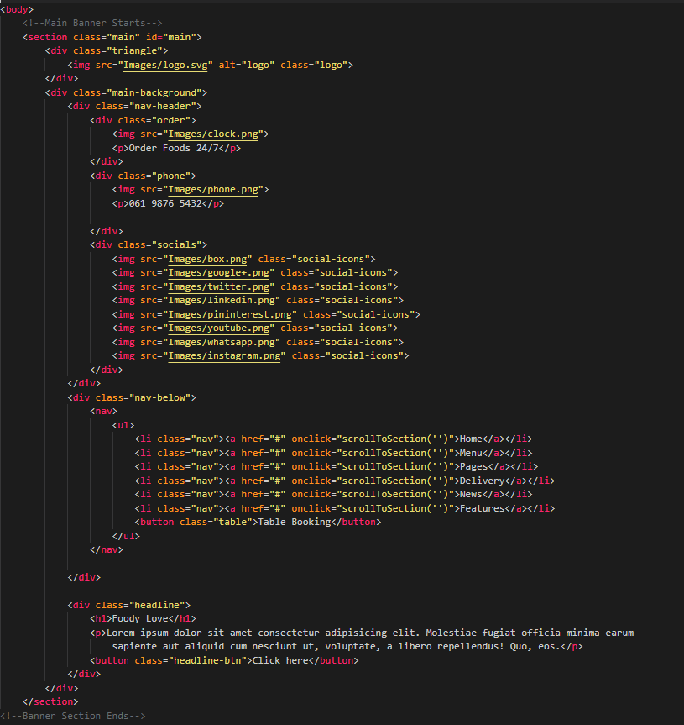

***Figure 2 HTML- Welcome Section***

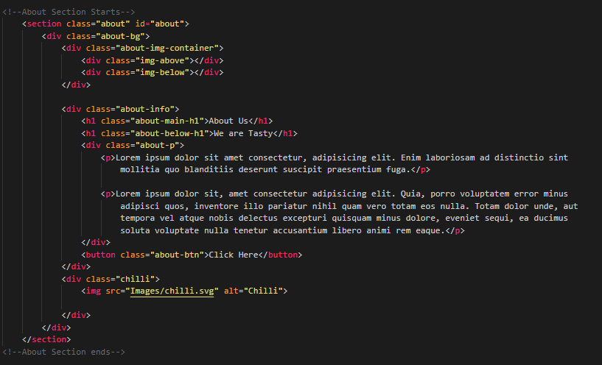

***Figure 3 HTML - About Section***

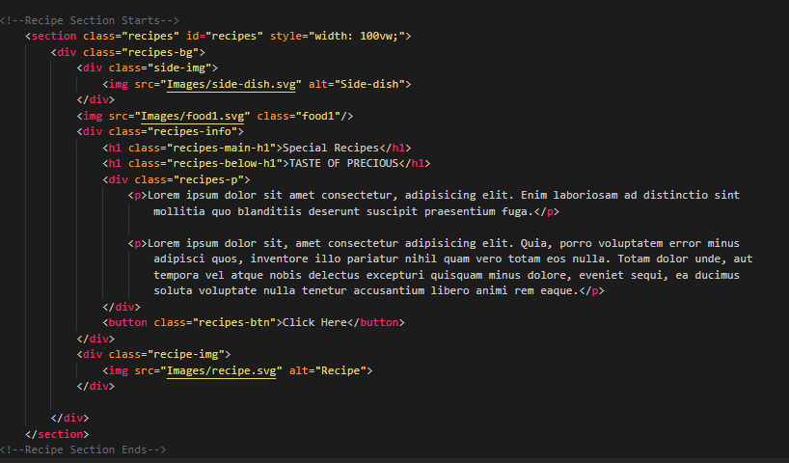

***Figure 4 HTML - Recipe Section***

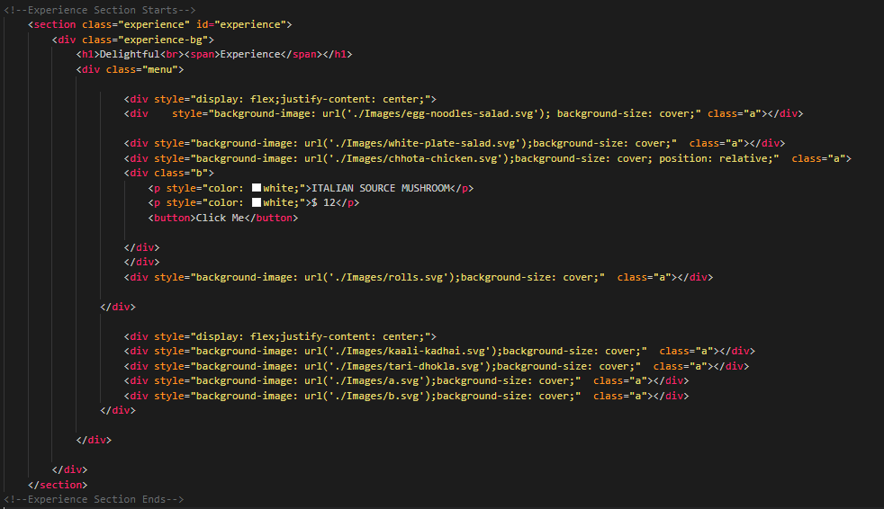

***Figure 5 HTML - Experience Section***

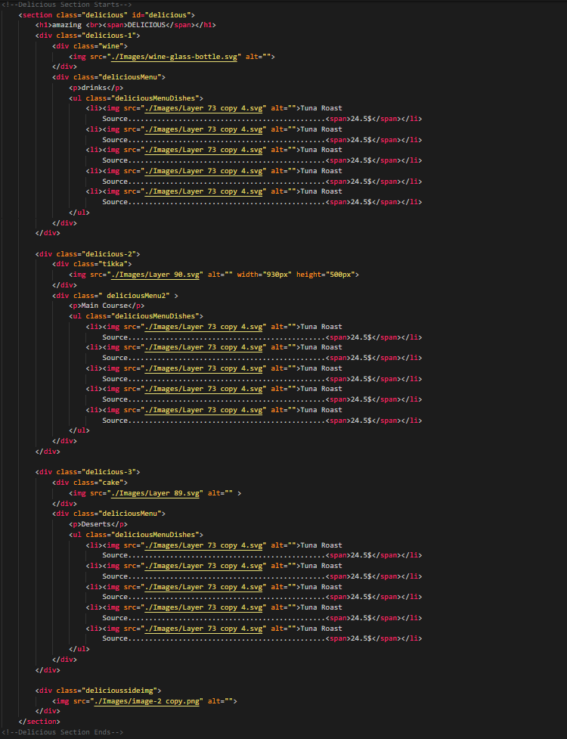***Figure 6 HTML - Delicious Section***

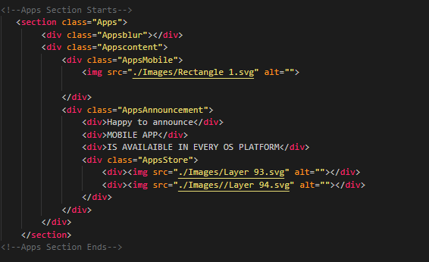

***Figure 7 HTML - Apps Section***

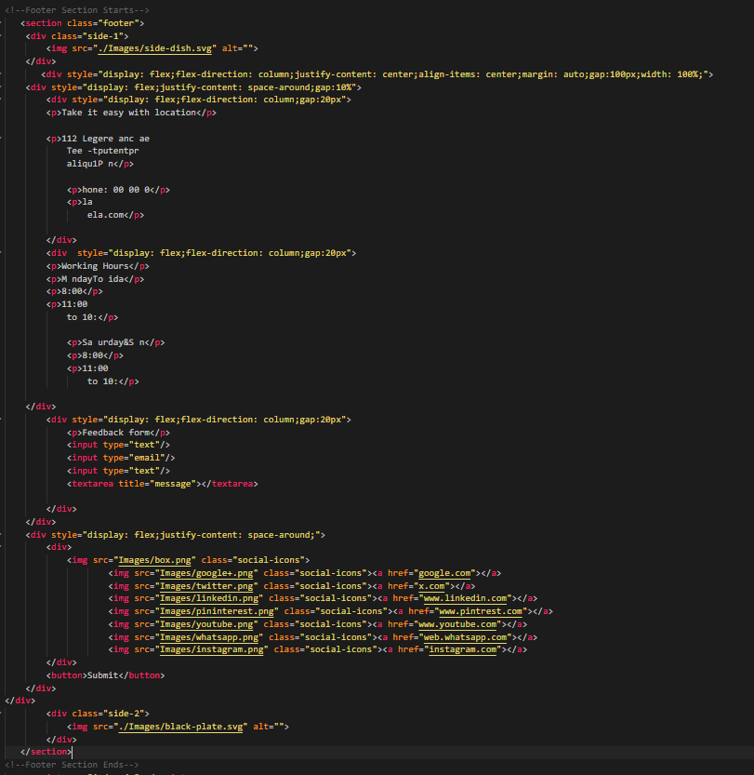***Figure 8 HTML - Footer Section***

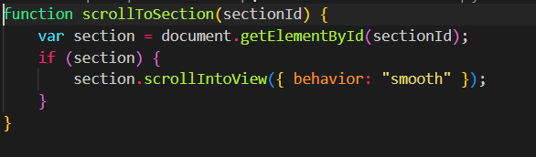

***Figure 11 Javascript***

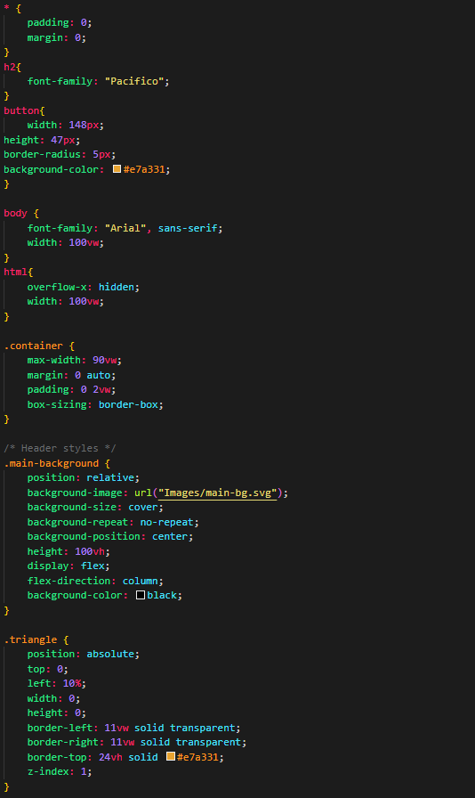

***Figure 12 CSS***

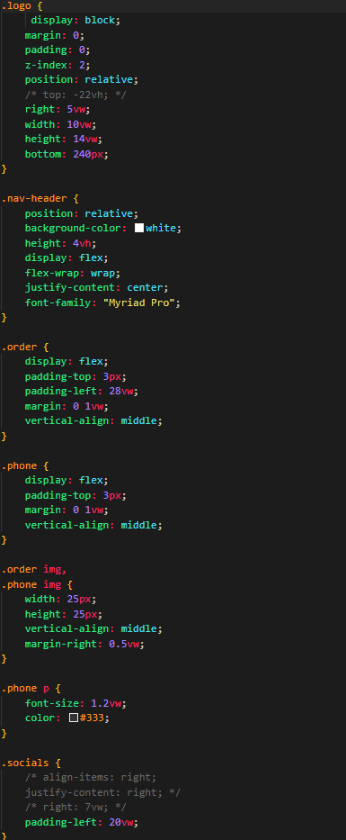

***Figure 13 CSS***

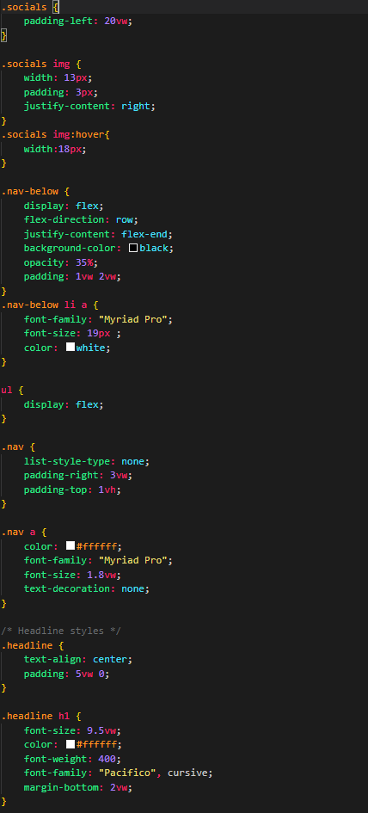

***Figure 14 CSS***

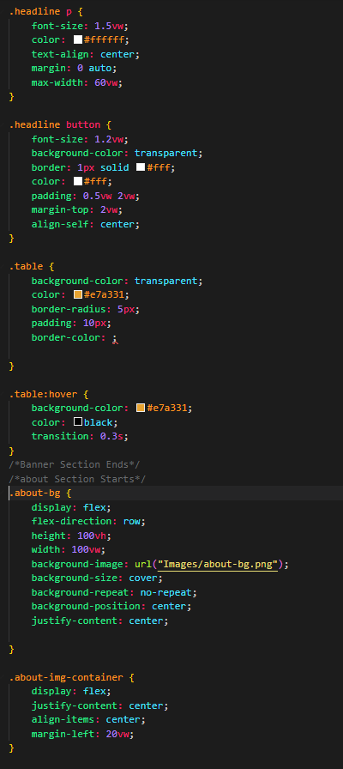

***Figure 15 CSS***

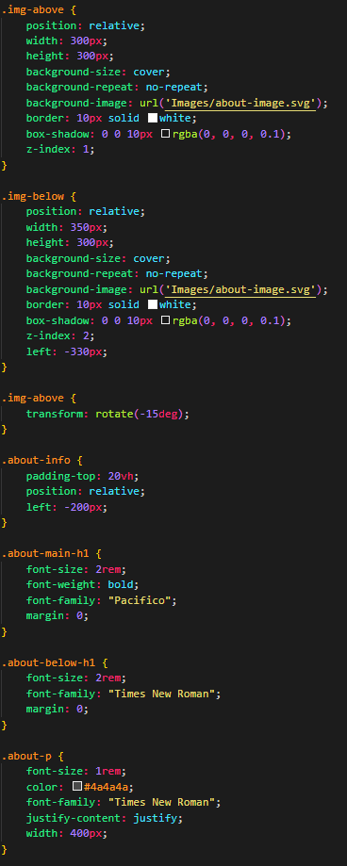

***Figure 16 CSS***

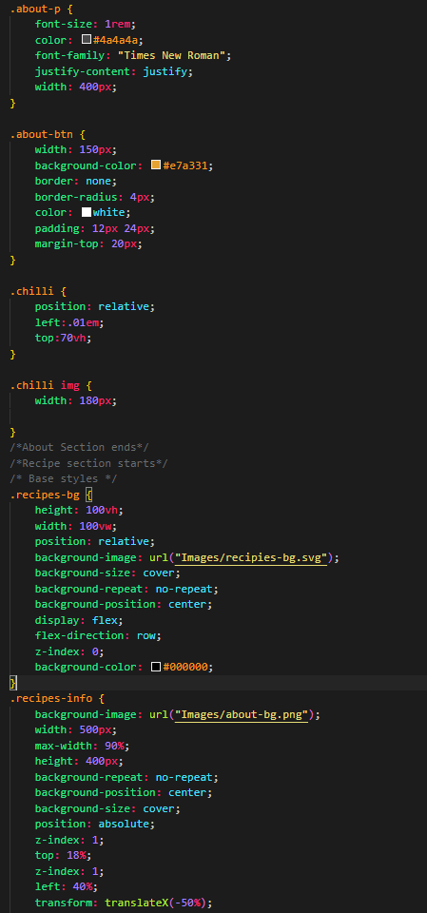

***Figure 17 CSS***

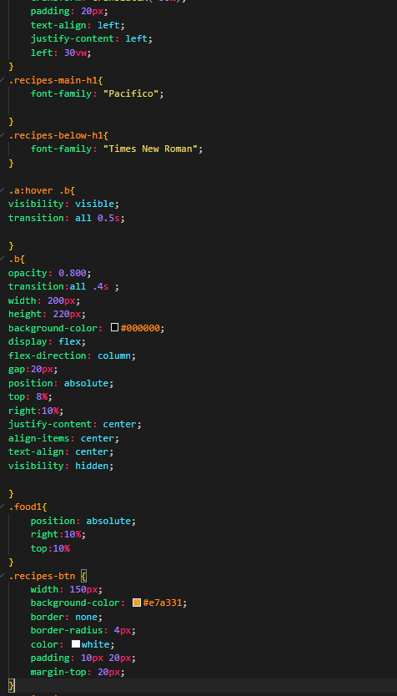

***Figure 18 CSS***

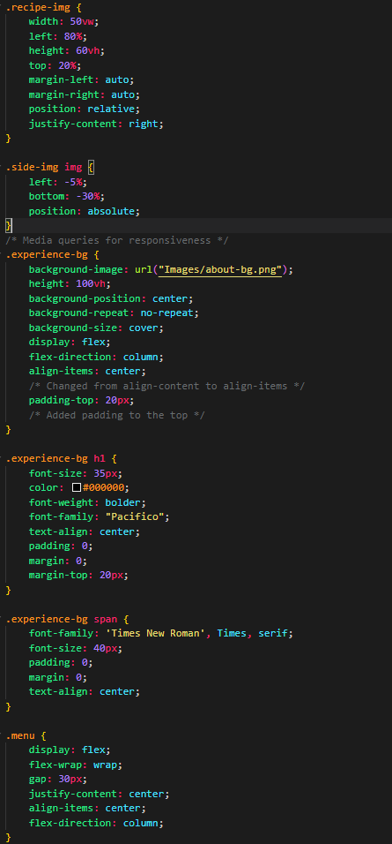

***Figure 19 CSS***



***Figure 20 CSS***

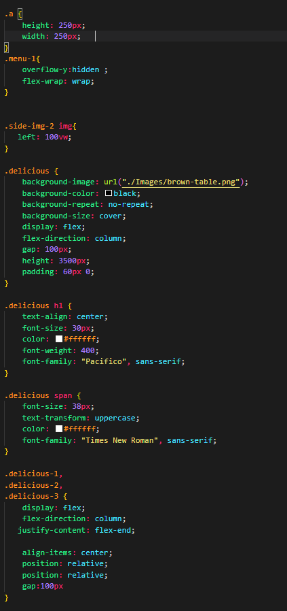

***Figure 21 CSS***

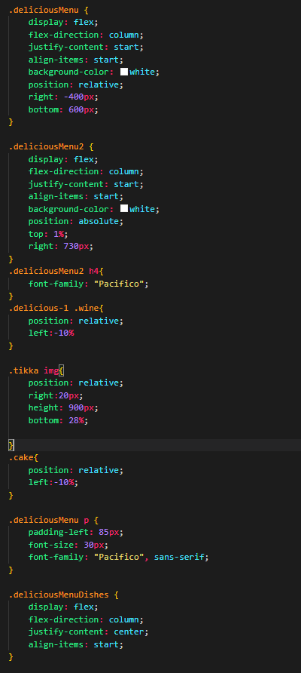

***Figure 22 CSS***

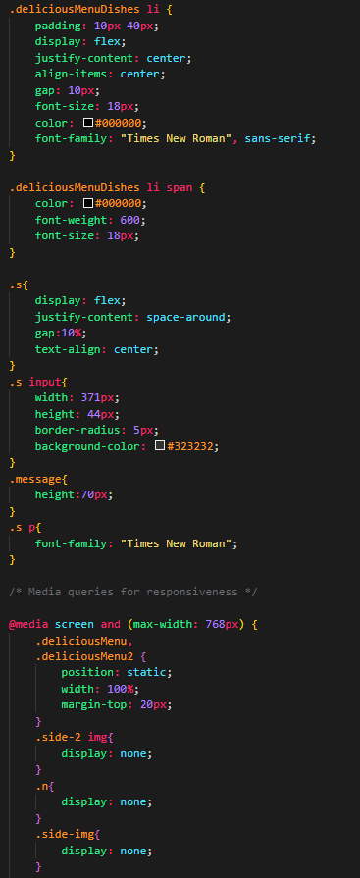

***Figure 23 CSS***

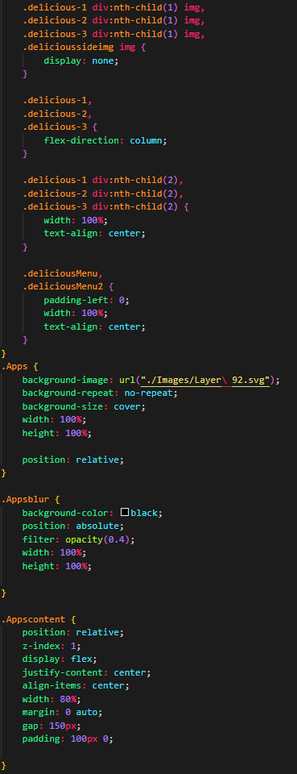

***Figure 24 CSS***

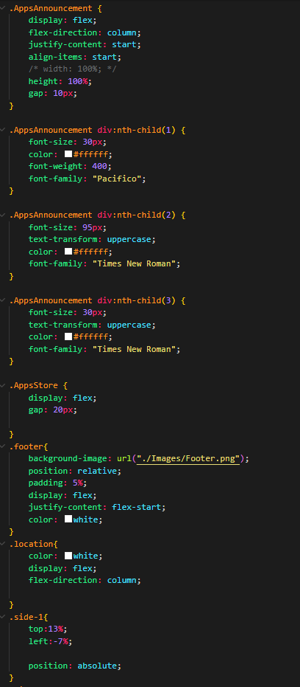

***Figure 25***

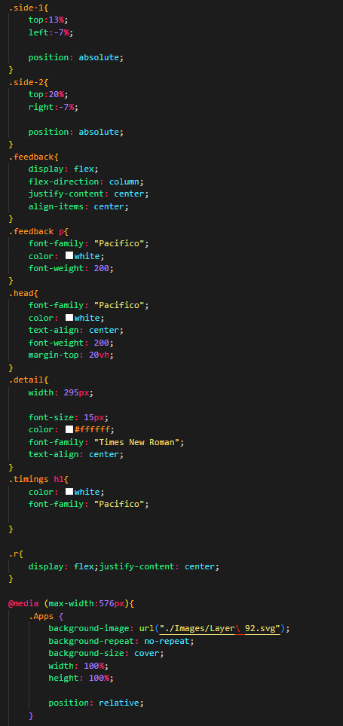

***Figure 26***

***e)***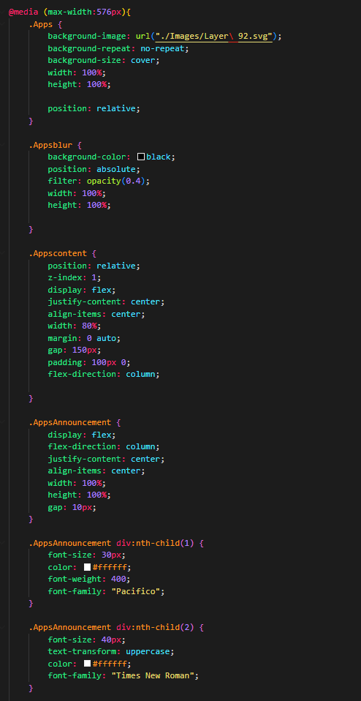

***Figure 27***

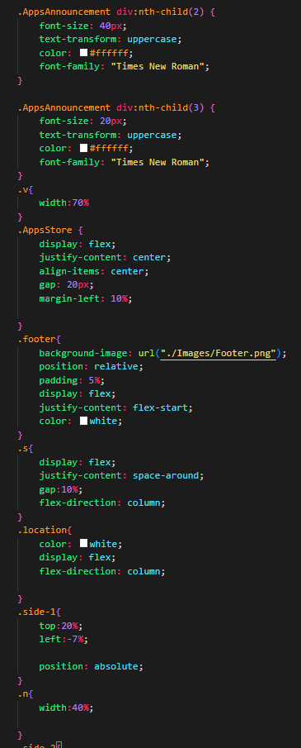

***Figure 28***

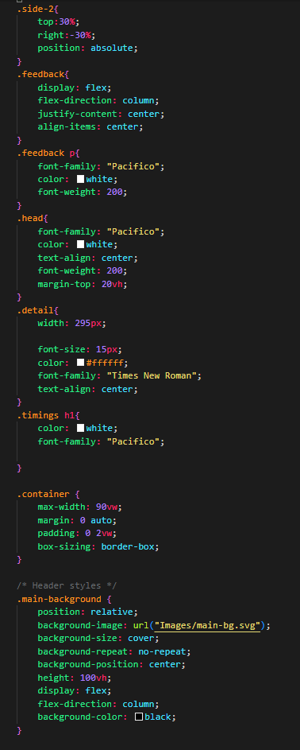

***Figure 29***

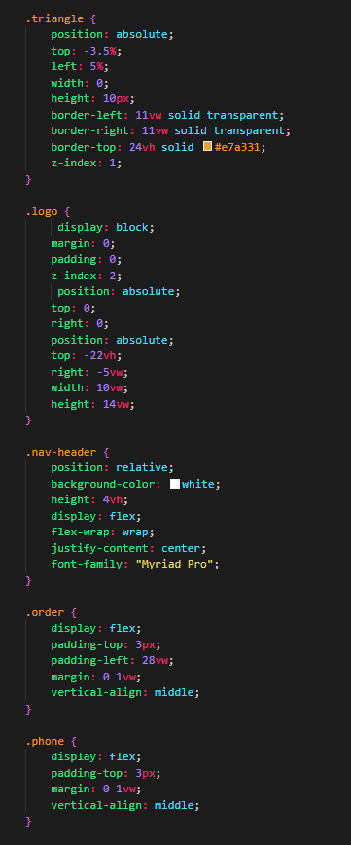

***Figure 30***

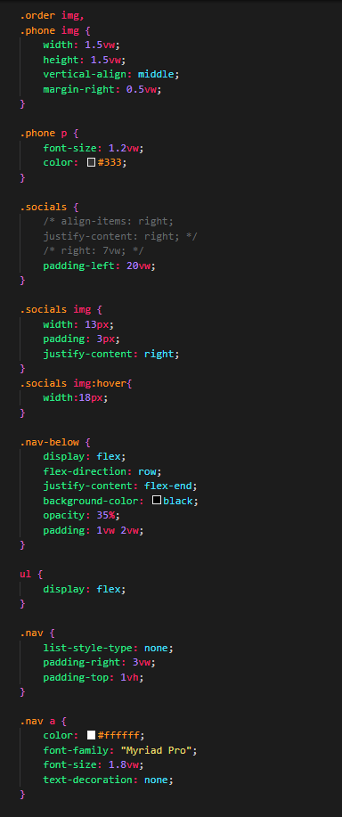

***Figure 31***

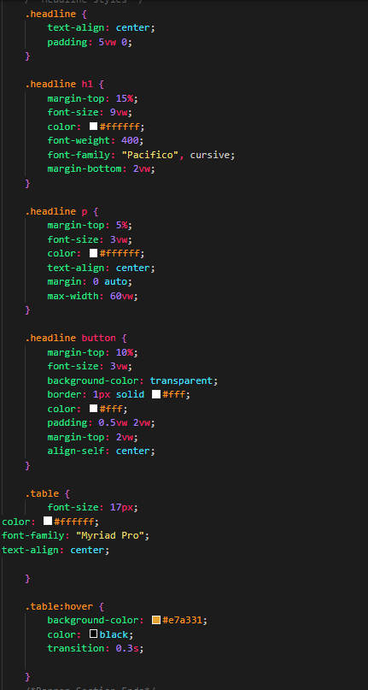

***Figure 32***

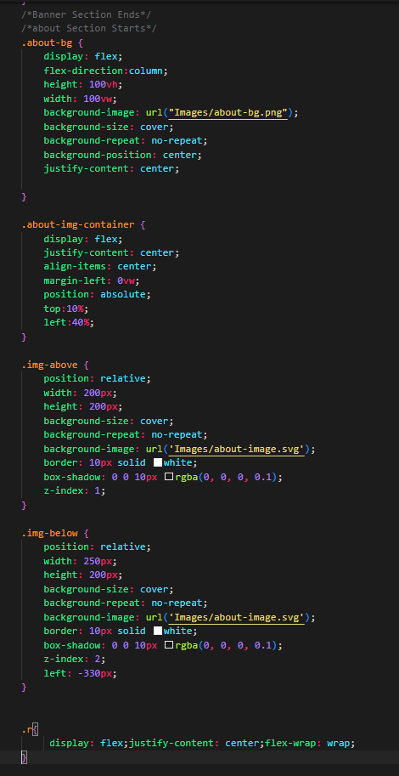

***Figure 33***

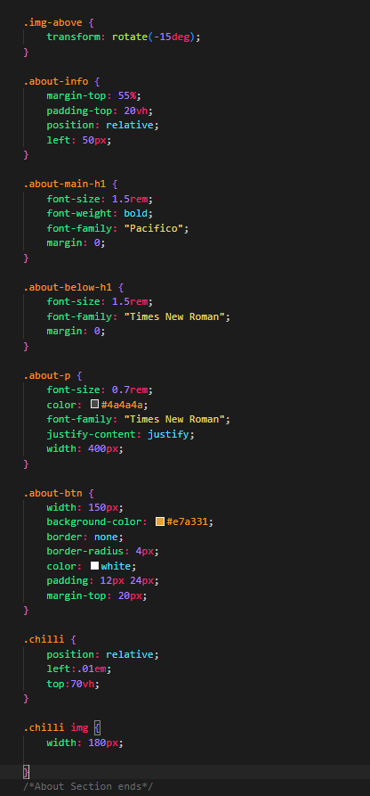

***Figure 34***

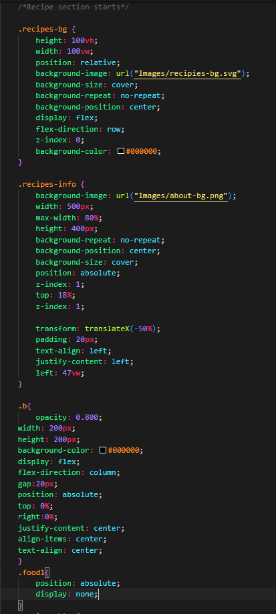

***Figure 35***

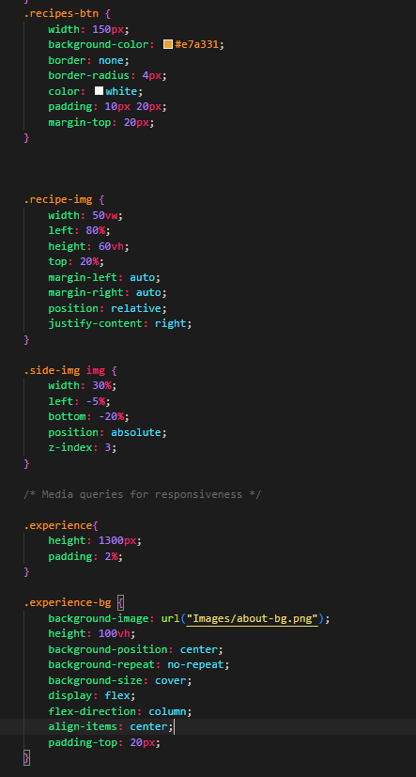

***Figure 36***

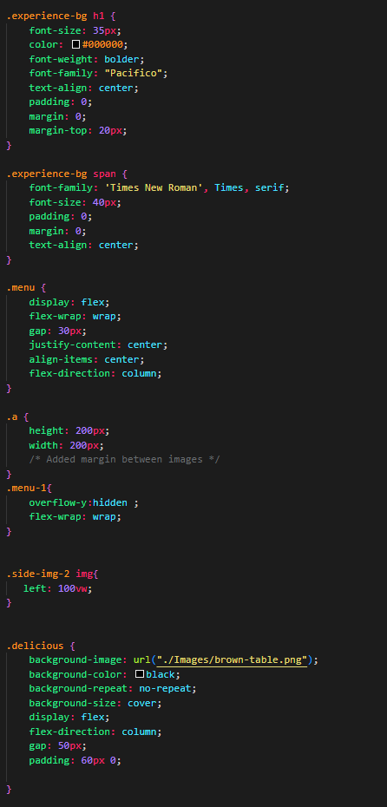

***Figure 37***

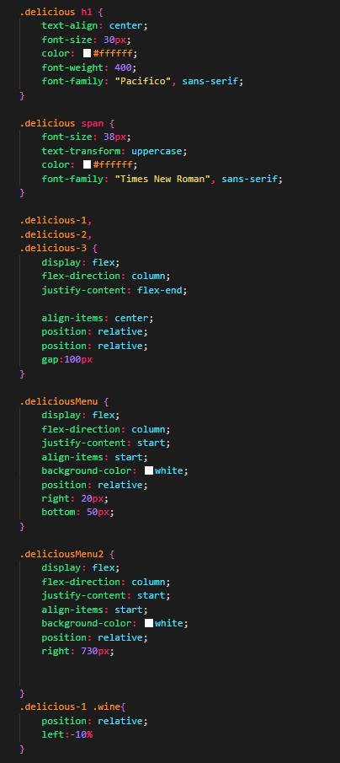

***Figure 38***

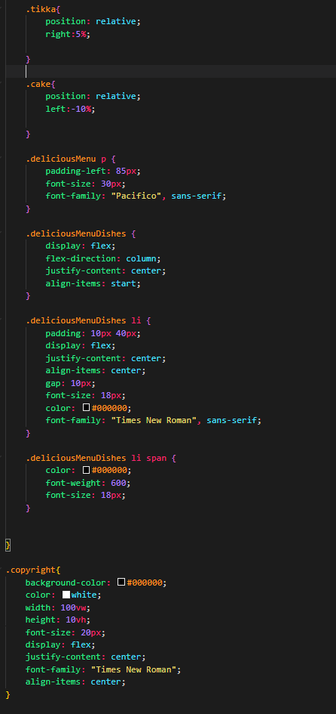

***Figure 39***

**References**

1. [www.photopea.com](http://www.photopea.com)
2. [www.w3schools.com](http://www.w3schools.com)
3. [www.psdFreebies.com](http://www.psdfreebies.com)
4. <https://fonts.google.com/>